**PRESS RELEASE:**

For media enquiries please contact

Melissa Hawker [melissa.hawker@norfolk.gov.uk](mailto:melissa.hawker@norfolk.gov.uk)  or Oliver Bone [oliver.bone@norfolk.gov.uk](mailto:oliver.bone@norfolk.gov.uk)

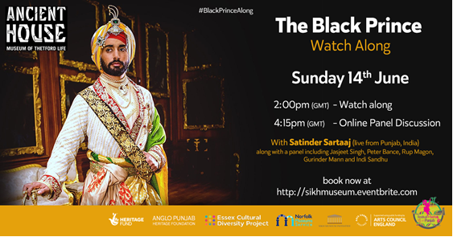

**The Black Prince Film Watch Along Event Sunday 14th June starting at 2pm**

Ancient House, Museum of Thetford Life and the Sikh Museum Initiative are hosting an exciting media event around the life of Maharajah Duleep Singh, last Maharajah of Punjab and Squire of Elveden Hall, near Thetford, Norfolk UK – a virtual screening of the 2017 film, ‘The Black Prince’ starring Satinder Sartaaj, Indian singer, songwriter, actor and poet, followed by an after-show discussion on Facebook Live.

Audiences around the world are invited to press ‘play’ at 2pm on Sunday 14th June on the film (via Netflix, DVD, or other streaming services) and follow along with the chat on Twitter via the hashtag #BlackPrinceAlong. Ancient House, the Sikh Museum Initiative, Essex Cultural Diversity Project and others will be tweeting historical context and interesting information along the way.

At 4.15pm there will be a Facebook Live event, supported by Taranjit Singh-Developer/technologist at Taran3d, with a panel to chat about the film and an opportunity for discussion and asking questions.  The panel will be chaired by Melissa Hawker, Learning Officer, Norfolk Museums Service and feature contributions from Satinder Sartaaj, who played Maharajah Duleep Singh, Peter Bance, Sikh Historian, Rup Magon who played Arur Singh in the film, Gurinder Mann Singh from the Sikh Museum Initiative, Festival of Norfolk and Punjab Director Indi Sandhu, and film producer Jasjeet Singh. The virtual audience are invited to submit questions via Twitter or on the chat. You can book your space in the virtual room via this link: <https://www.eventbrite.co.uk/e/the-black-prince-watch-along-tickets-108081927956?fbclid=IwAR0ZMw9XzKu-2oLRI-95e_nzgSDQwcN_B_CkfKf_tA9yW2kNVzdV0micuL8>

‘The Black Prince’ is a 2017 international historical drama film directed by Kavi Raz and features the acting debut of Satinder Sartaaj.The film explores the troubled life of Maharaja Duleep Singh - the last king of Punjab whose kingdom was taken from him by the British in the 1840s. Duleep Singh was separated from his mother and brought to England where he was befriended by Queen Victoria.  He was allowed to return to India only twice under controlled circumstances and tried to regain his kingdom in later life.

Speaking about the event Satinder Sartaaj said: “It is wonderful to know that my film is bringing people around the world together to view the story of the last Maharajah of Punjab from their own homes. I am looking forward to answering questions during the after-show discussion.”

Cllr. John Ward, Chairman of the Norfolk Joint Museums Committee, Norfolk County Council said: “We’re delighted that Ancient House Museum is involved in this exciting digital event. The Museum owes its existence to the Duleep Singh family as it was the Maharajah’s son, Prince Frederick Duleep Singh, who gave Ancient House to the people of Thetford. In recent years, staff at the museum have been working to research and interpret this important story, collaborating with the Sikh Museum Initiative and Essex Cultural Diversity Project on two major cultural festivals connecting Thetford, Norfolk and Punjab. This latest event will further extend these links – we hope it’ll bring people together from across the world to enjoy a fascinating shared experience.”

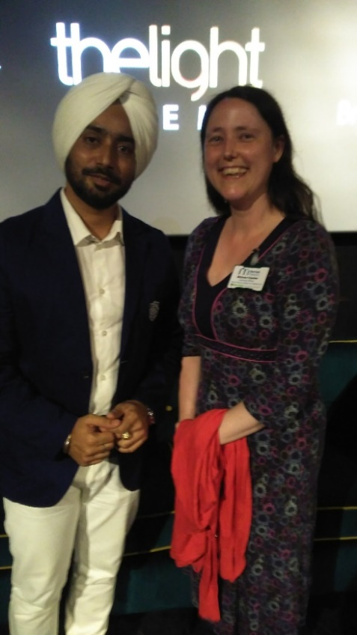

Melissa Hawker with Satinder Sartaaj who plays Maharajah Duleep Singh at the showing of the Black Prince in Thetford in 2017

Print of Maharajah Duleep Singh (1838 – 1893)

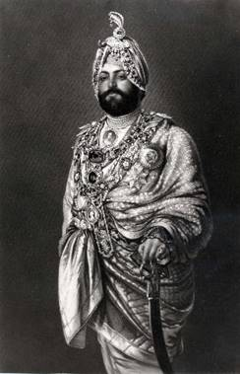

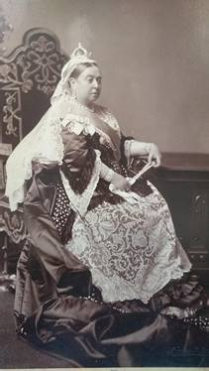

Photograph of Queen Victoria (1819 – 1901), a gift to the Maharajah in 1882

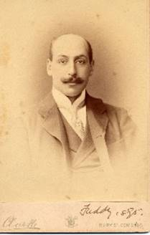

Prince Frederick Duleep Singh (1868 – 1926), son of the Maharajah and donor of the Ancient House to the town of Thetford for use as a public museum.

NOTES TO EDITORS:

**About Ancient House, Museum of Thetford Life**

The Ancient House was given to the people of Thetford by Prince Frederick Duleep Singh, son of Maharajah Duleep Singh of Punjab. The Museum has worked in partnership with the Sikh Museum Initiative and Essex Cultural Diversity Project since 2018 over two major cultural festivals connecting Thetford, Norfolk and Punjab. Thetford’s Ancient House is part of Norfolk Museums Service, a multi-award winning service comprising ten museums and a study centre. Norfolk Museums Service is a partnership between Norfolk County Council and Norfolk's district councils, funded through council tax, earned income and grants.  <https://www.museums.norfolk.gov.uk/ancient-house>

**About The Sikh Museum Initiative (SMI).**

The SMI explores the Historical World of the Sikhs.  There has been a long history linking the Sikhs to the British since the eighteenth century. This history is relatively unknown and requires an initiative to bring closer introspection and investigation. As a result the Sikh Museum Initiative will focus on locating and uncovering relics and documents which binds the two communities together. This national programme will leave a lasting legacy for future generations so that second generation Sikhs will understand the close relationship that exists.  <https://www.sikhmuseum.org.uk/>

**About Taran3D**

Taran3D is a team of designers who are passionate about heritage, storytelling and design. We combine rigorous research, interpretive planning, high levels of creativity and technical know-how to tell stories through inspiring interpretive visitor experiences. Founded in 2015, we have delivered numerous successful projects for clients throughout the UK. Our multidisciplinary team of designers and developers have developed intelligent and creative interpretation and educational solutions for numerous museums, heritage projects, community groups and engineering firms. <https://www.taran3d.com/>

**About Essex Cultural Diversity Project**

Essex Cultural Diversity Project (ECDP) breaks down barriers and promotes cultural harmony in Essex and the wider region. Through arts, cultural and heritage projects we raise awareness of race equality and cultural diversity, benefiting all people within communities across Essex. We work strategically with artists, the culture and heritage sector, the BAME community and the voluntary sector to help develop skills, build sustainable networks and infrastructures, alongside creating new opportunities to enhance BAME artists’ work. ECPD have worked with partners to direct the Festival of Norfolk and Punjab

<https://essexcdp.com/>



**Black Prince Watchalong**

Sunday 14th June 2020 2pm start, 4.15pm panel discussion

Ancient House, Museum of Thetford Life

White Hart Street

Thetford

IP24 1AA  [www.museums.norfolk.gov.uk](http://www.museums.norfolk.gov.uk)